2400040454
Harsha Vardhan.

Ex. No.: 11 Series in Parllel connection.
AIM
To practice soldering and de-soldering for the electronic circuit by assembling and disassembling in the Printed Circuit Board (PCB) and check for its Continuity.

APPARATUS REQUIRED
S.NO | NAME OF THE  APPARATUS | RANGE | QUANTITY
1. | PCB Board | - | 1
2. | Soldering iron | 60/40 grade | 1
3. | Solder | - | As Required
4. | Soldering Flux | - | As Required
5. | Capacitor | 100μf | As Required
6. | Resistor | 1kΩ | As Required
7. | Multimeter | - | 1

- The flux also assists in the transfer of heat from the soldering iron tip to the joint area.

SOLDERING:
CIRCUIT DAIGRAM:
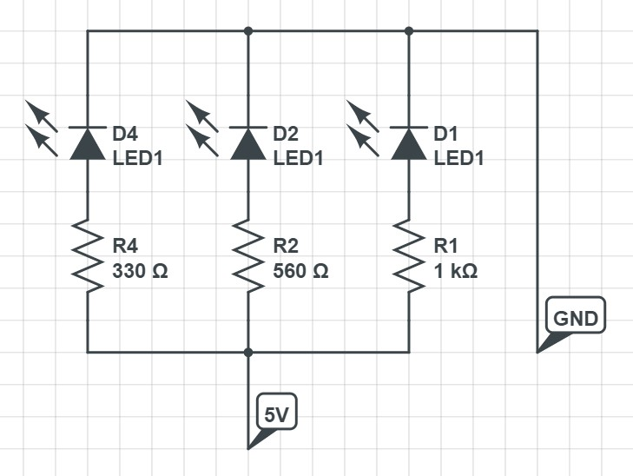

PROCEDURE:
SOLDERING (SERIES CONNECTION):
- Login to Tinkercad website through your mail ID and choose the circuit option by clicking on new button.

- In the search option find the required components like resistor, power supply, multimeter, breadboard, etc.
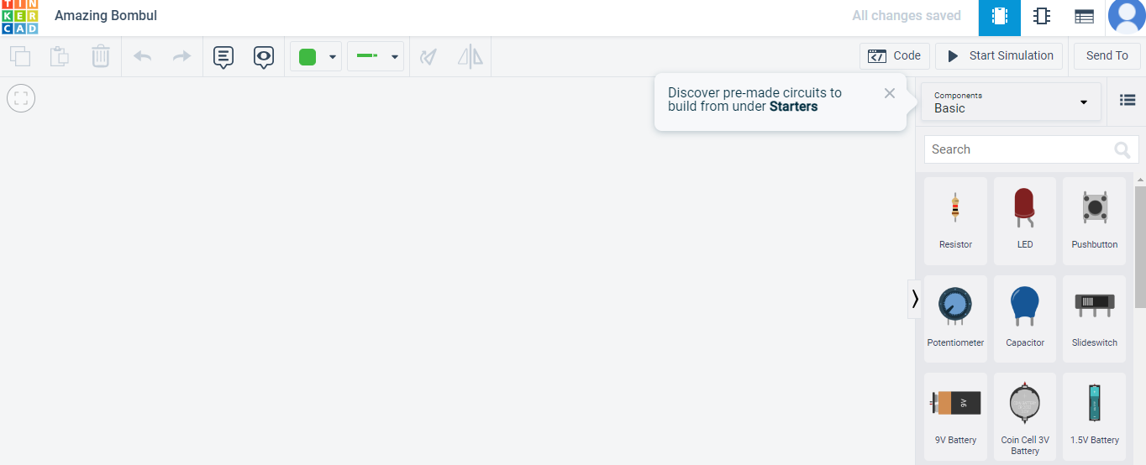
- Select the breadboard and 4 resistors from search option and arrange in series connection in the workspace provided.
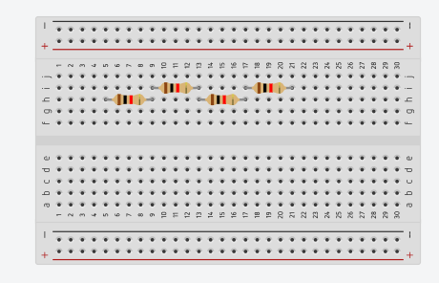

- Provide values to 4 resistors (in Ω) by clicking on each resistor (820, 220, 1600, 470).

- Now provide power supply by selecting power supply option in the search and give value as 12V.
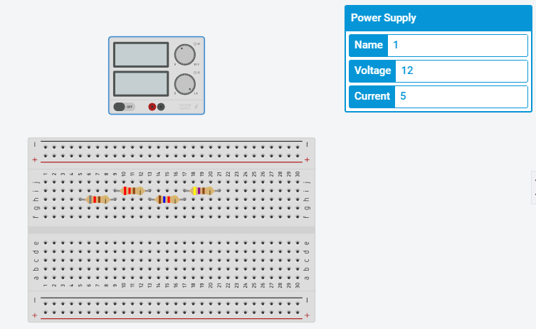

- Connect positive terminal of power supply with positive of breadboard. Repeat same for the negative terminals and connect multimeter.
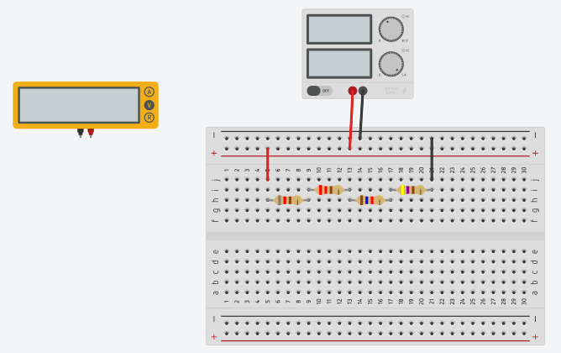

- Connect positive terminal of multimeter with positive of first resistor. Similarly do with negative terminal. Afterwards, click on the start simulation option, record the reading of multimeter (in V) and then click on stop simulation option.
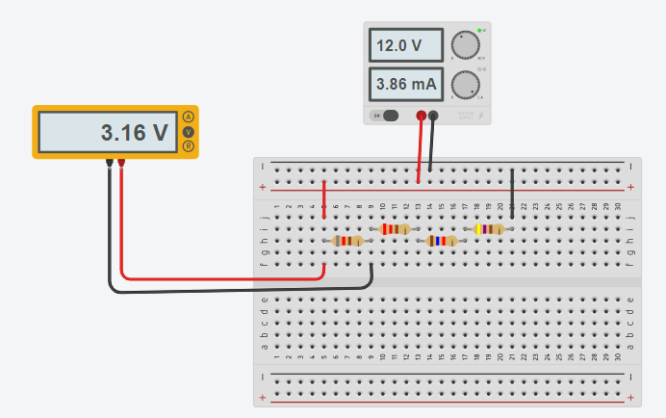

- Follow step 7 for the remaining resistors and record the voltage readings.

- Add all the values of voltage and it should come equal to input voltage (i.e. 12V).

- Similarly, we can cross check the current value by changing the wire connections and recording the current reading from the multimeter.
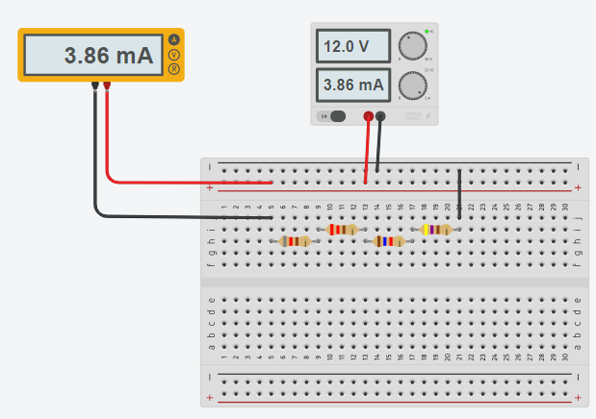

OBSERVATION:
S. No. | Resistor (Ω) | Voltage (V)
1 | 820 | 3.16
2 | 220 | 0.849
3 | 1600 | 6.17
4 | 470 | 1.81

Input voltage = 12 V.
Output voltage = 3.16 + 0.849 + 6.17 + 1.81 = 11.989 V
RESULT:
Thus the soldering for the electronic circuit for series connection is verified.

